Deploy tomcat in multiple environments

Create and launch one instance

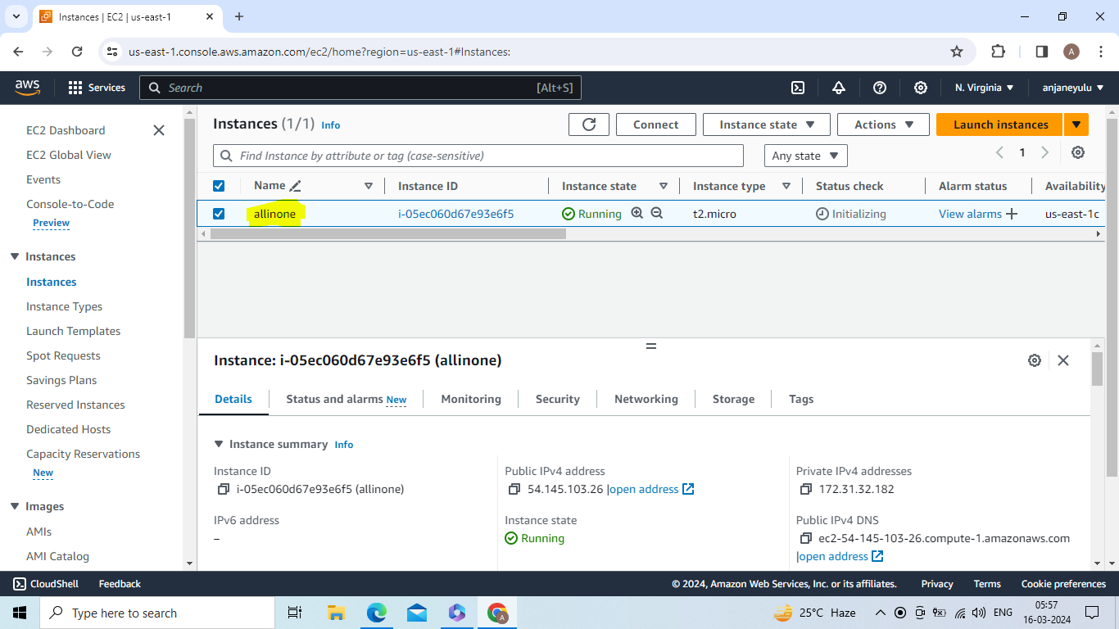

Go to security -->security group -->actions--> edit inbound rules -->8080(jenkins) -->save rules

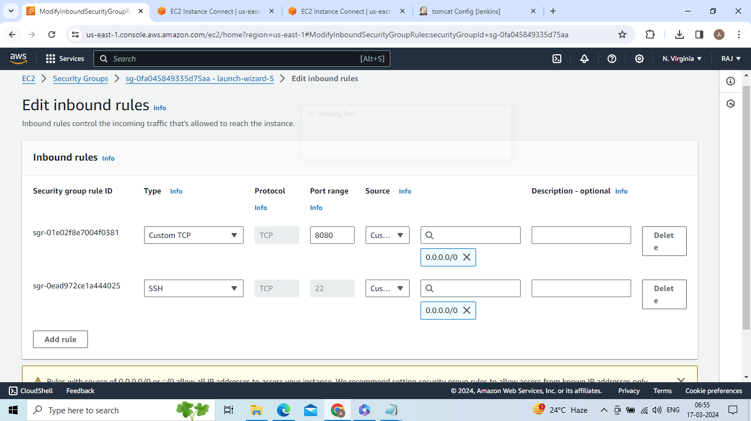

apt update -y && apt install maven -y && apt install default-jdk -y

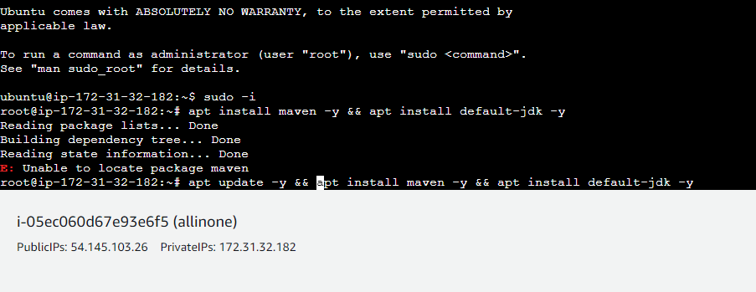

Install jenkins by using below commands

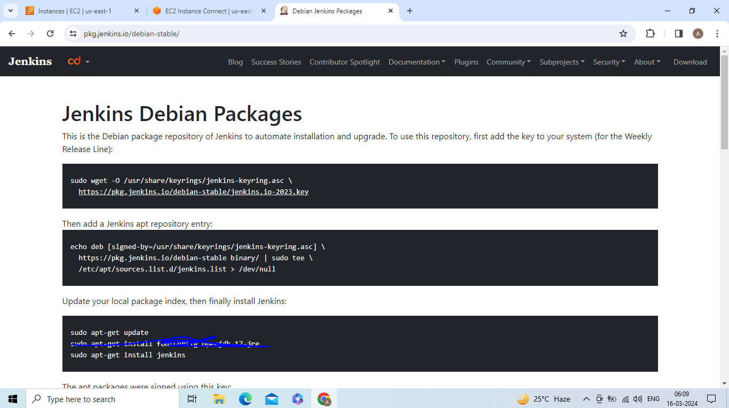

Copy public IP and port number 8080 and paste it in new page or browser then u get unlock jenkins page

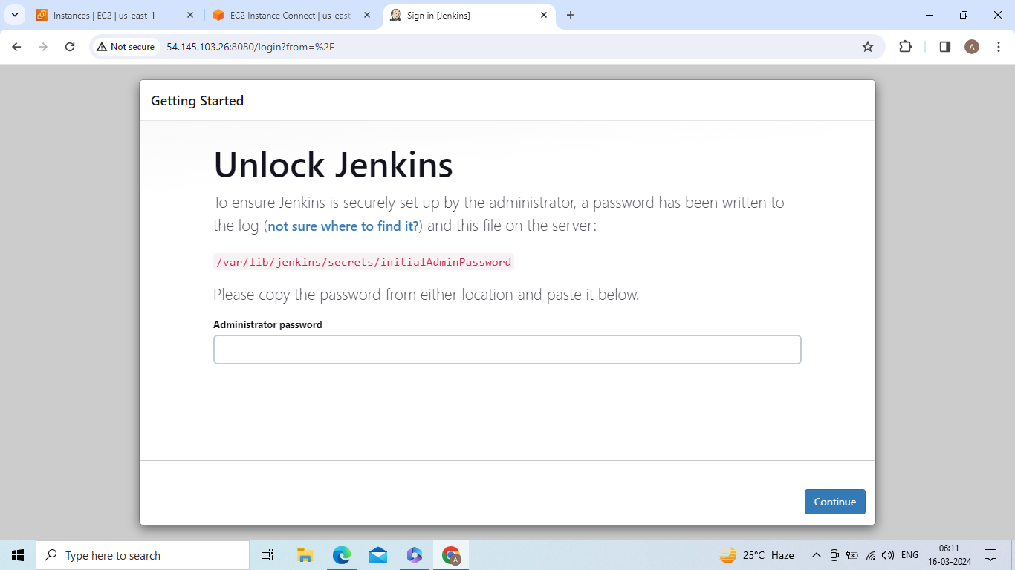

For **Administrator password copy above path paste it in server by using cat command**

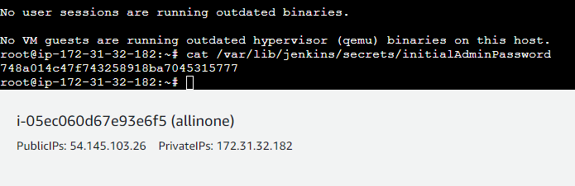

Copy password and paste it in unlock jenkins page

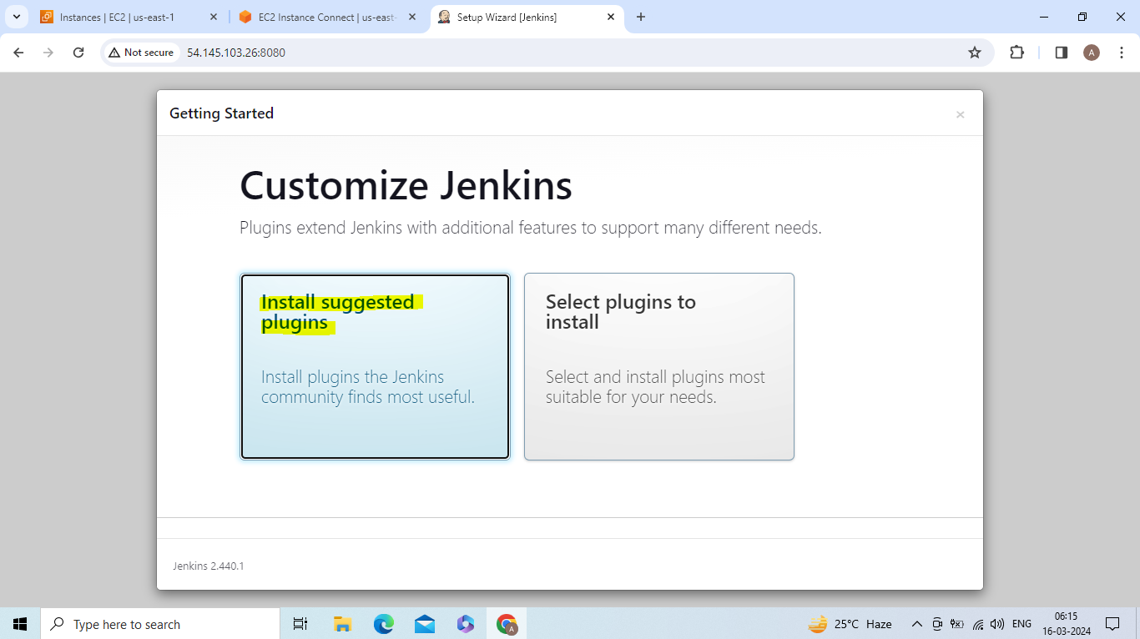

Login to jenkins by giving username, password,email,full name

Create and launch instance and install tomcat

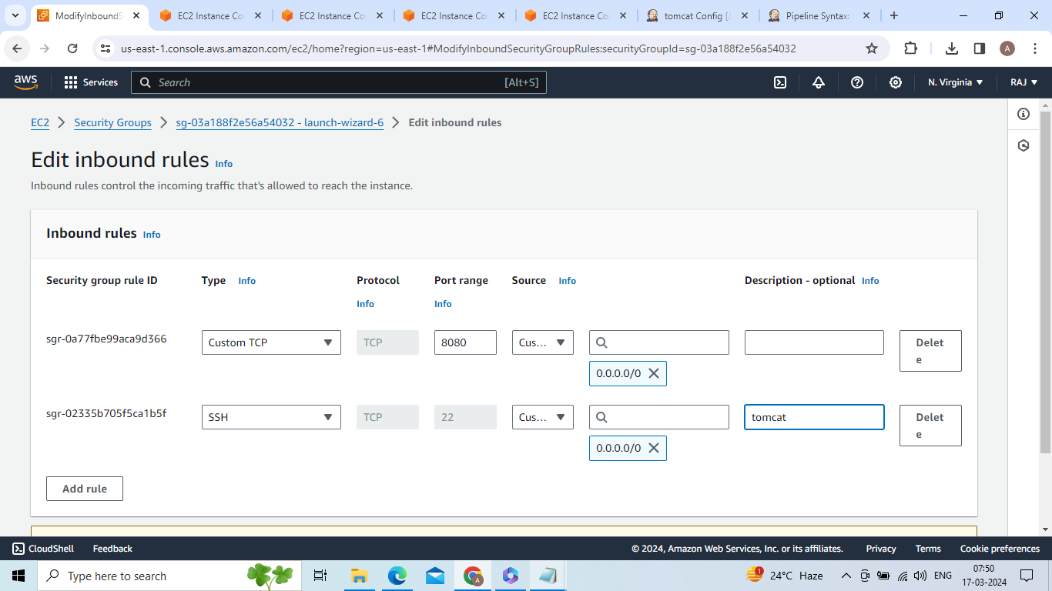

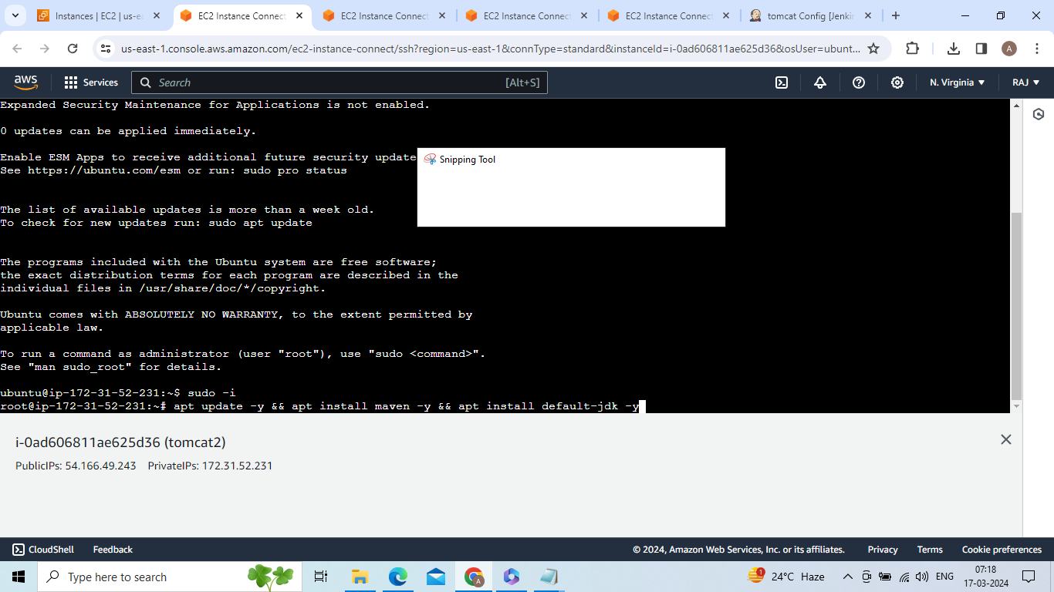

wget https://dlcdn.apache.org/tomcat/tomcat-9/v9.0.87/bin/apache-tomcat-9.0.87.tar.gz

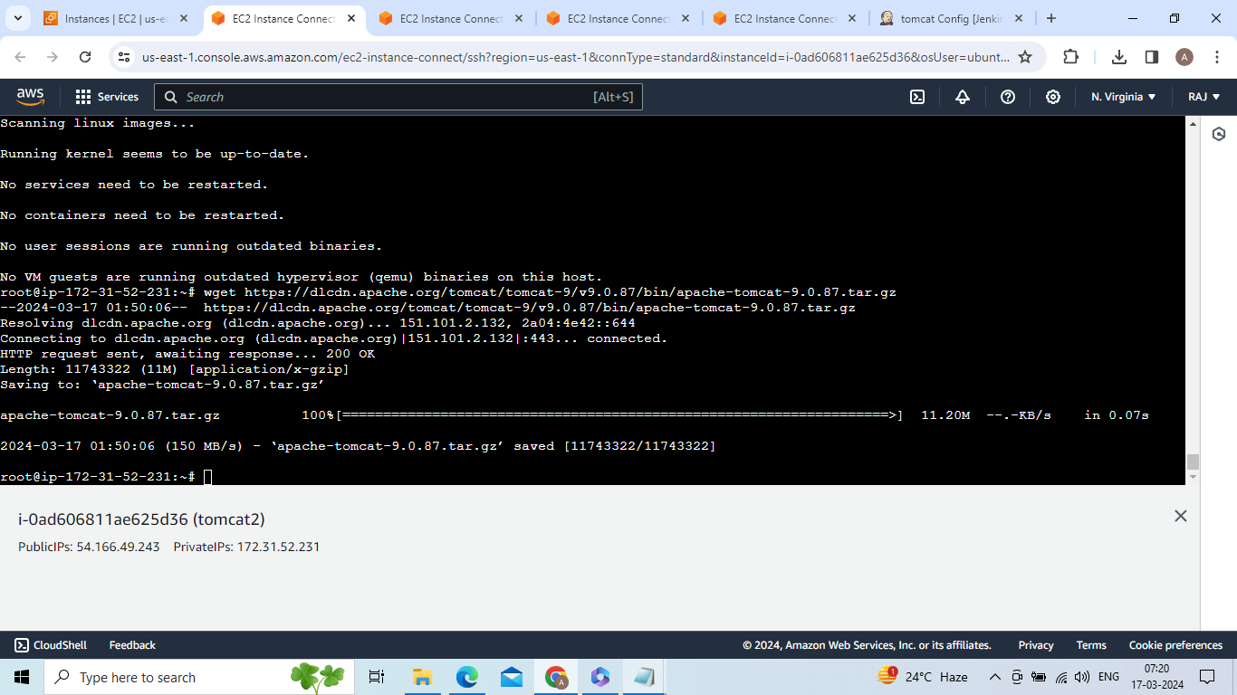

tar -xvzf apache-tomcat-9.0.87.tar.gz

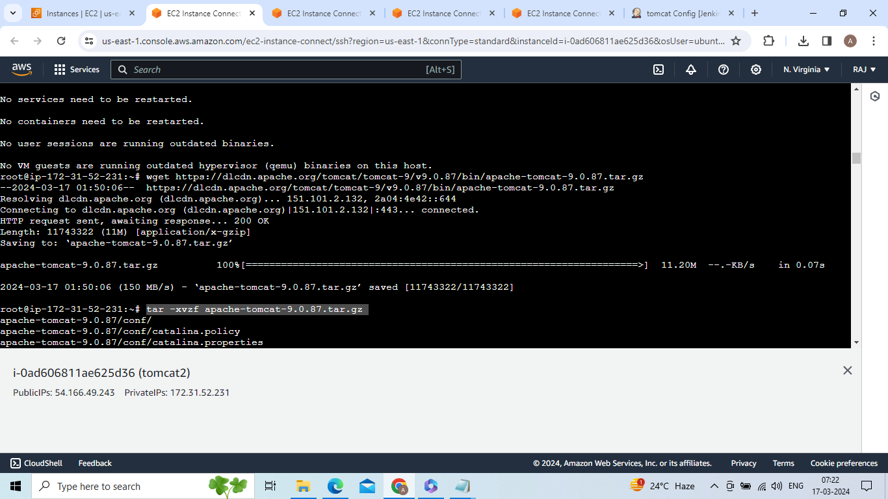

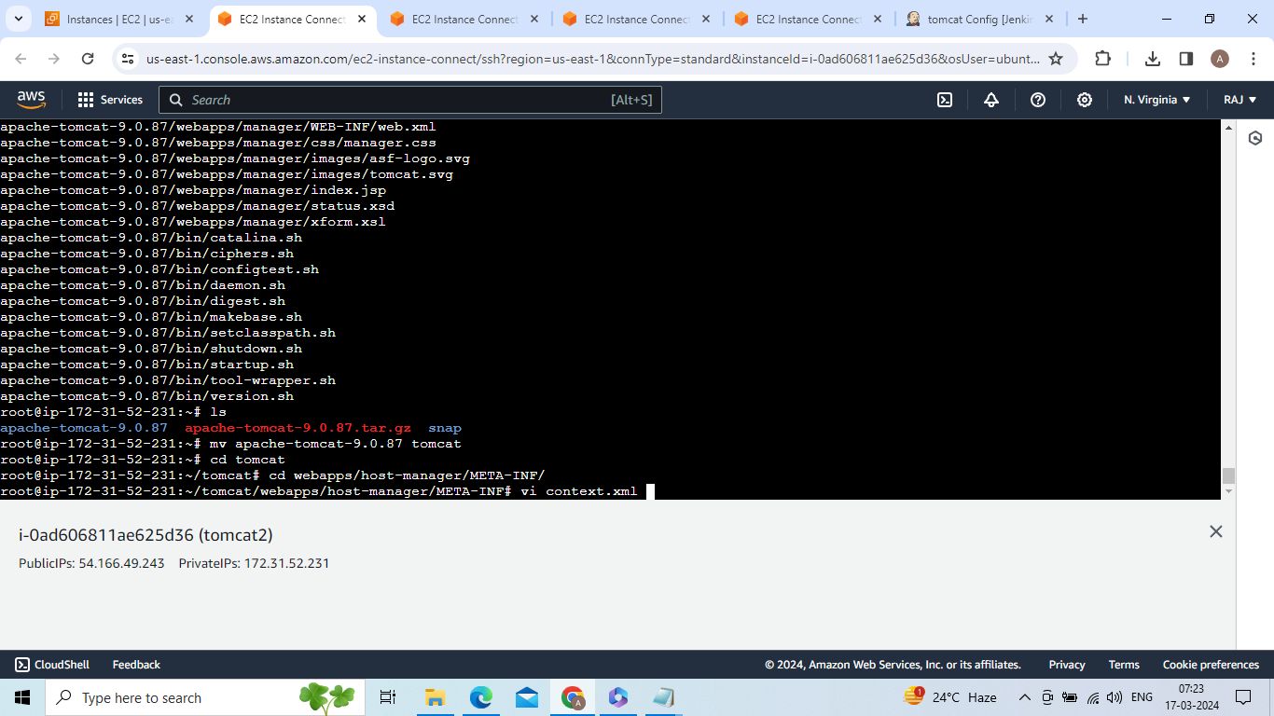

Comment two lines

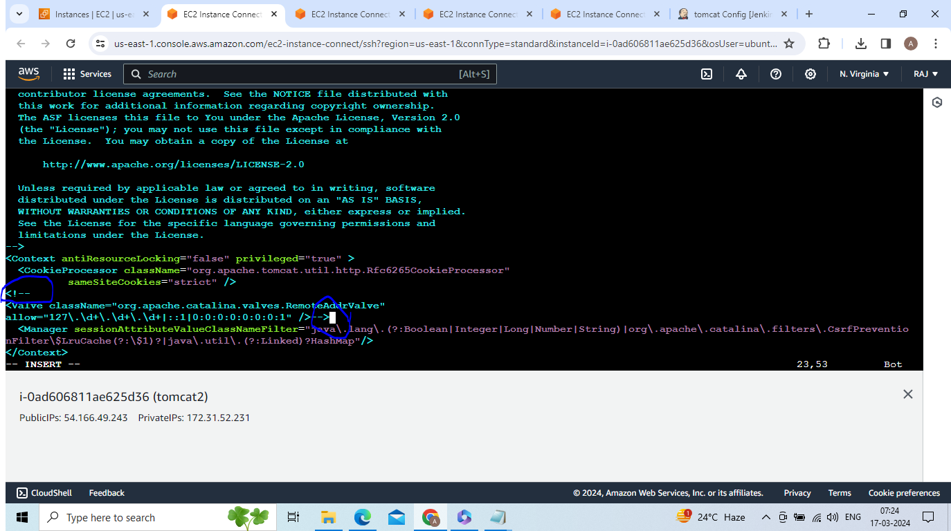

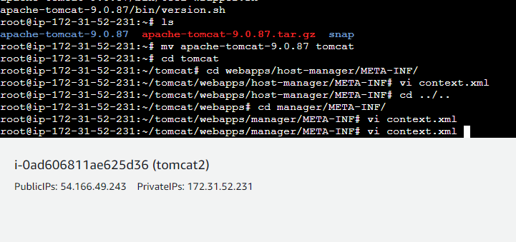

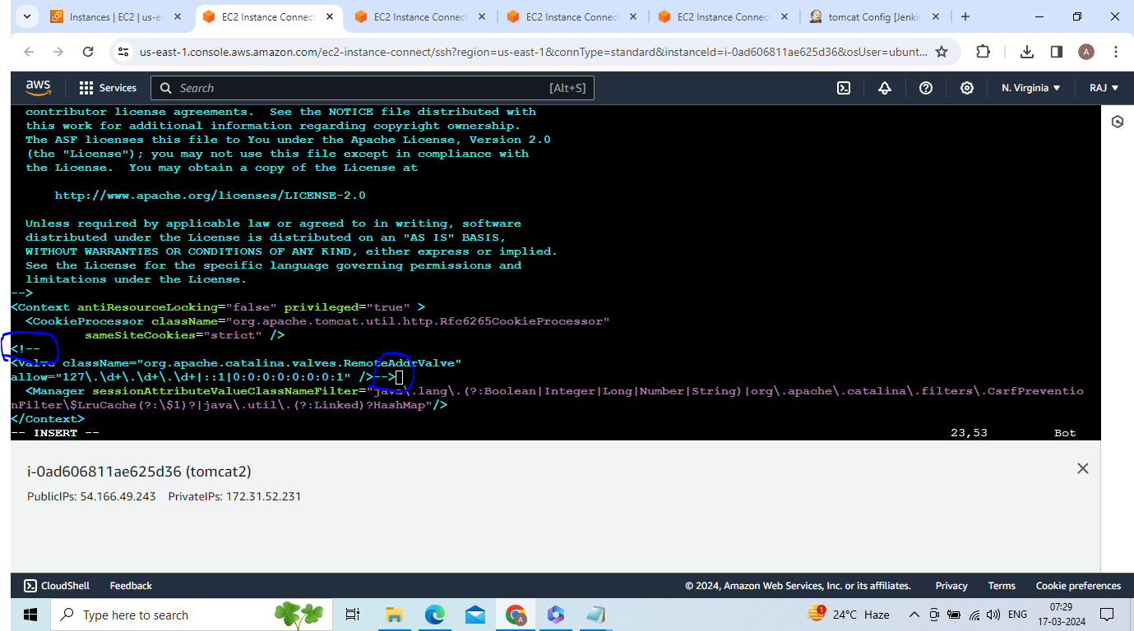

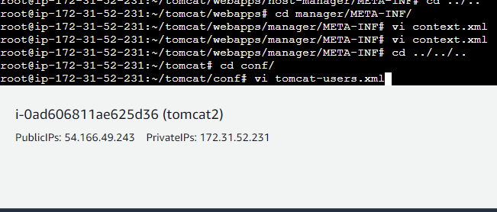

Paste below data in tomcat.xml

<role rolename="manager-gui"/>

<role rolename="manager-script"/>

<role rolename="manager-jmx"/>

<role rolename="manager-status"/>

<user username="admin" password="admin" roles="manager-gui, manager-script, manager-jmx, manager-status"/>

<user username="deployer" password="deployer" roles="manager-script"/>

<user username="tomcat" password="s3cret" roles="manager-gui"/>

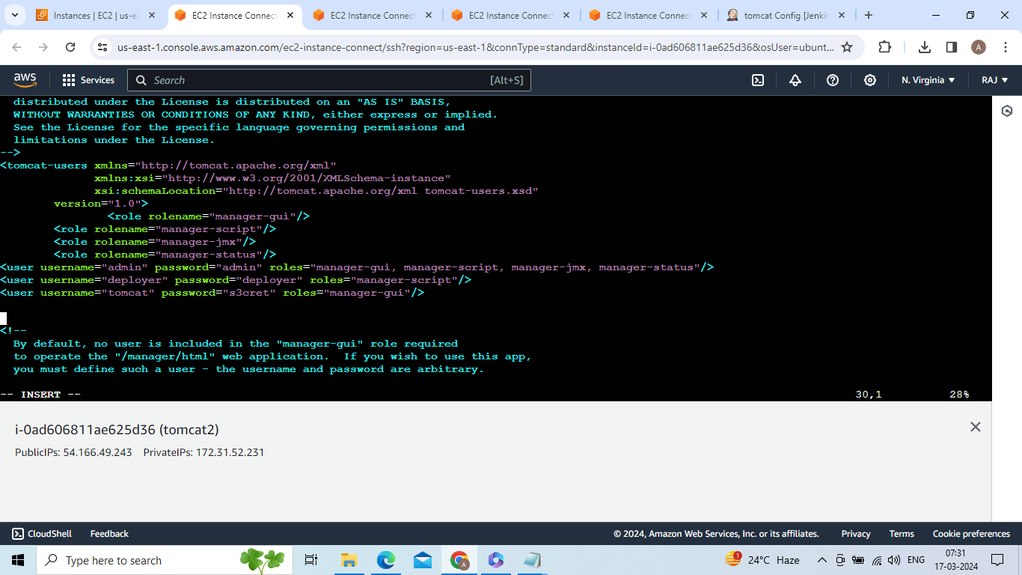

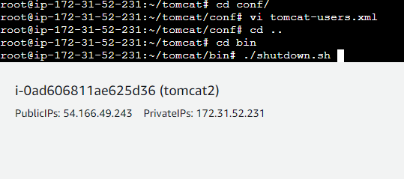

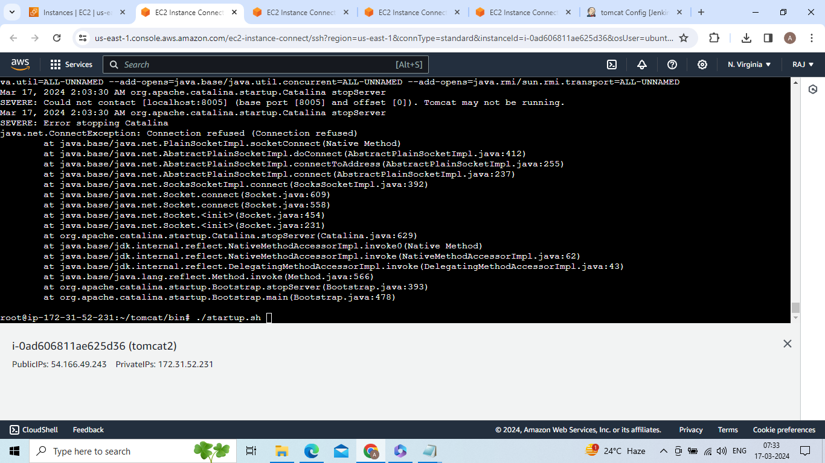

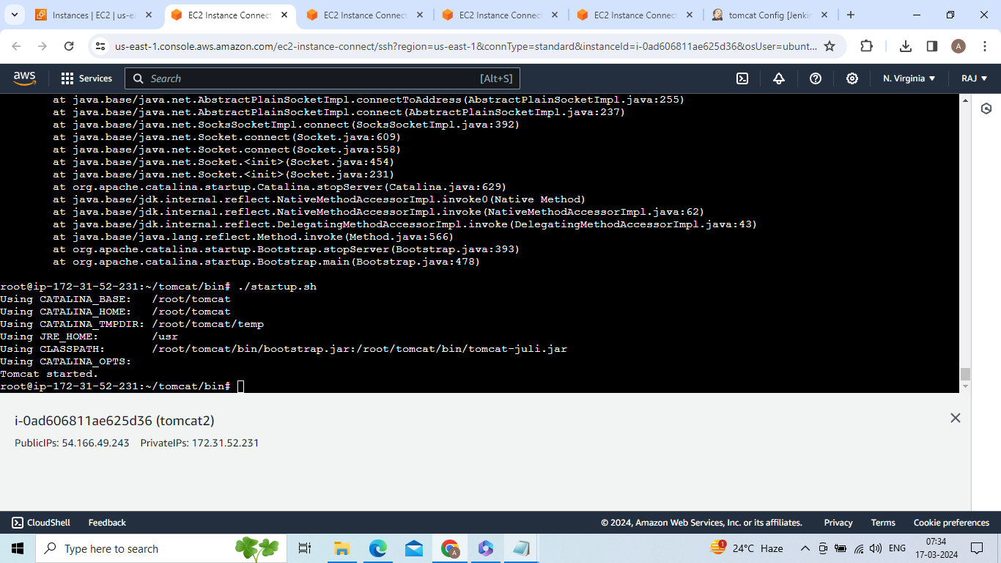

Go to jenkins(what you install) -->create one pipeline job -->pipeline syntax -->select deploy to container --> give all details

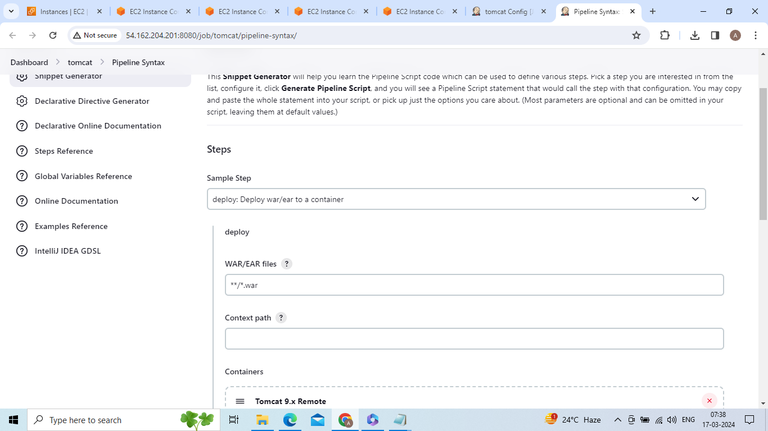

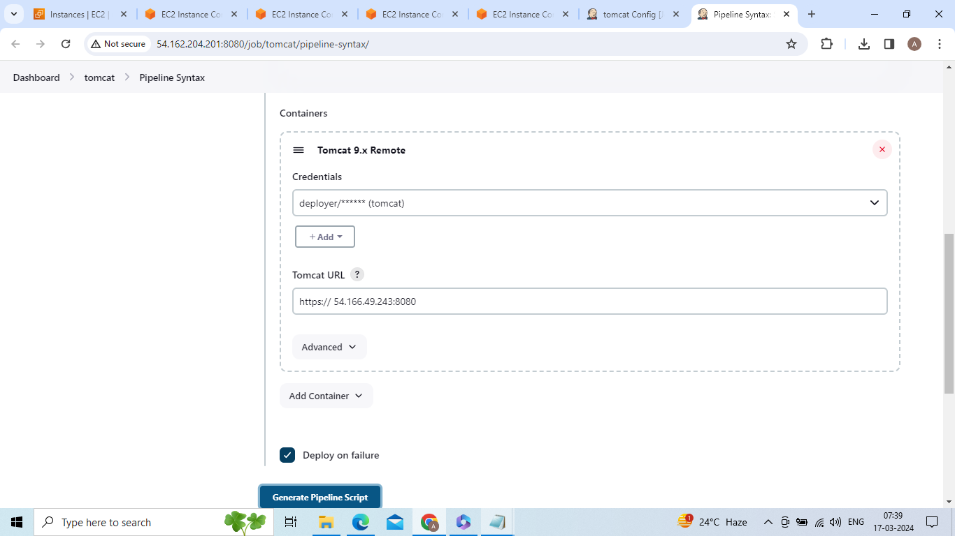

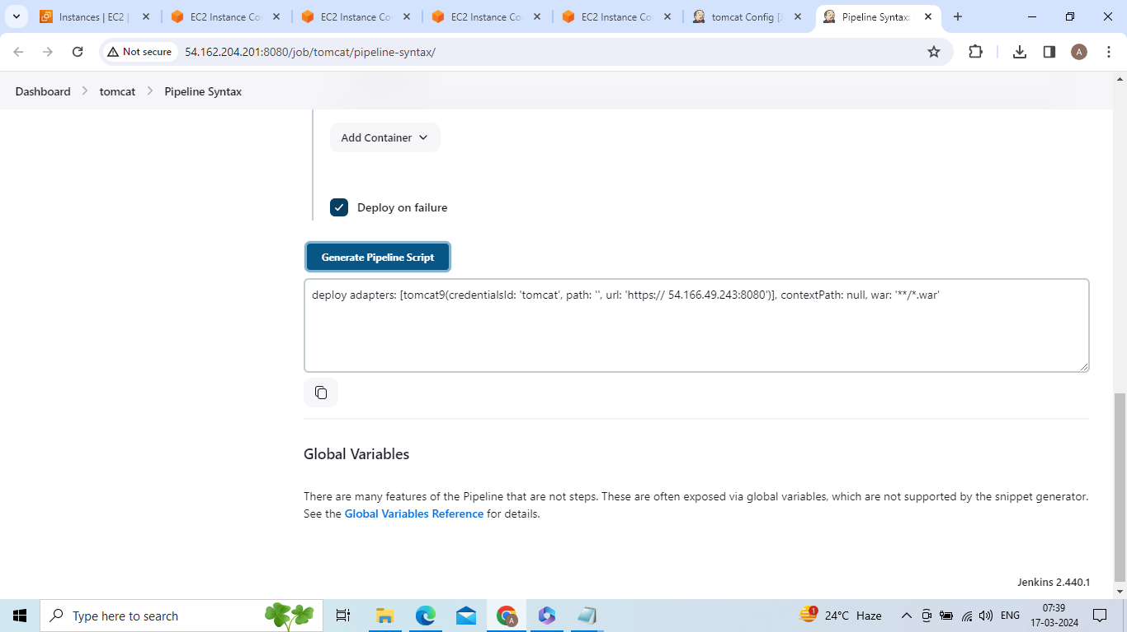

Similarly create and launch 3 instances and install tomcat and get URLs likr below URL

deploy adapters: [tomcat9(credentialsId: 'tomcat', path: '', url: 'https:// 54.166.49.243:8080')], contextPath: null, war: '**/*.war'

Go jenkins create on job with pipeline -->

Select parameters -->choice parameter

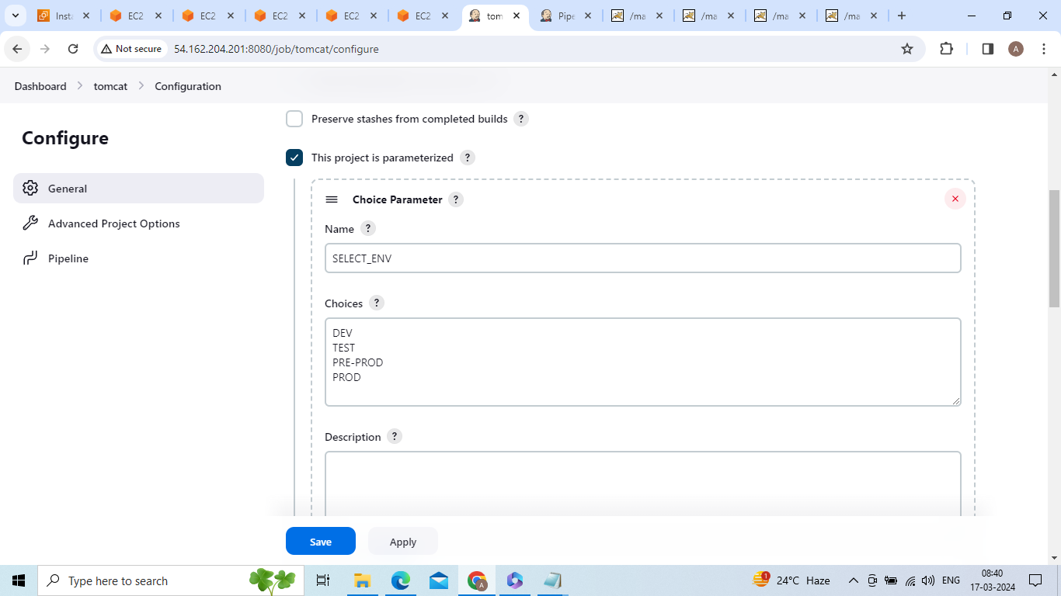

Write script like below

pipeline {

agent any

parameters {

choice(name : 'SELECT_ENV' , choices: ['DEV' , 'TEST' , 'PRE-PROD' , 'PROD'])

}

stages {

stage ("cloning git repoistory") {

steps {

echo 'cloning taxi-booking'

checkout scmGit(branches: [[name: '*/master']], extensions: [], userRemoteConfigs: [[url: 'https://github.com/anji103/taxi-booking.git']])

}

}

stage ("package") {

steps {

sh 'mvn package'

}

}

stage ("DEV_DEPLOY") {

when {

expression { params ['SELECT_ENV'] == 'DEV' }

}

steps {

deploy adapters: [tomcat9(credentialsId: 'tomcat', path: '', url: 'http://52.86.52.71:8080/')], contextPath: null, war: '**/*.war'

}

}

stage ("TEST_DEPLOY") {

when {

expression { params ['SELECT_ENV'] == 'TEST' }

}

steps {

deploy adapters: [tomcat9(credentialsId: 'tomcat1', path: '', url: 'http://52.201.186.246:8080/')], contextPath: null, war: '**/*.war'

}

}

stage ("PRE_PROD") {

when {

expression { params ['SELECT_ENV'] == 'PRE-PROD' }

}

steps {

deploy adapters: [tomcat9(credentialsId: 'tomcat2', path: '', url: 'http://54.166.49.243:8080/')], contextPath: null, war: '**/*.war'

}

}

stage ("PROD") {

when {

expression { params ['SELECT_ENV'] == 'PROD' }

}

steps {

deploy adapters: [tomcat9(credentialsId: 'tomcat3', path: '', url: 'http://54.160.109.14:8080/')], contextPath: null, war: '**/*.war'

}

}

}

}

Apply and save

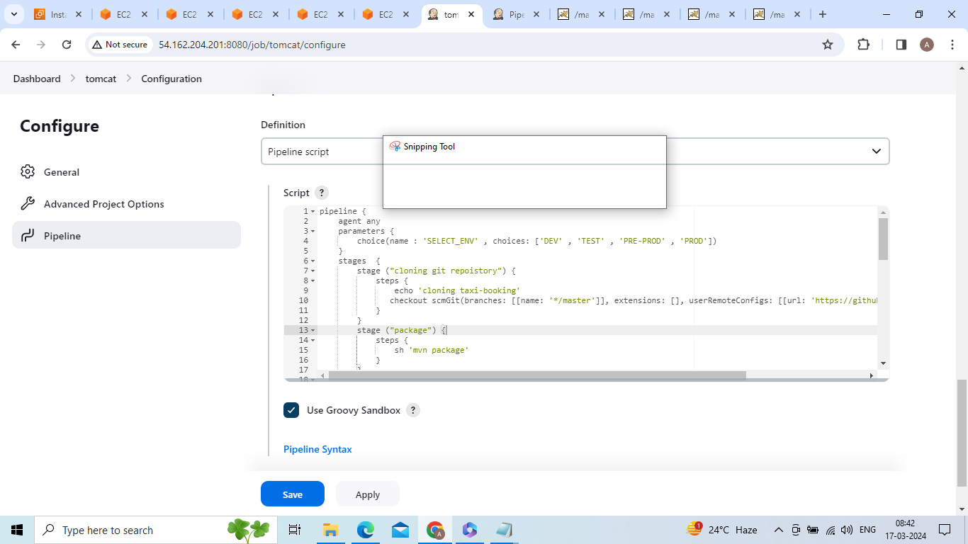

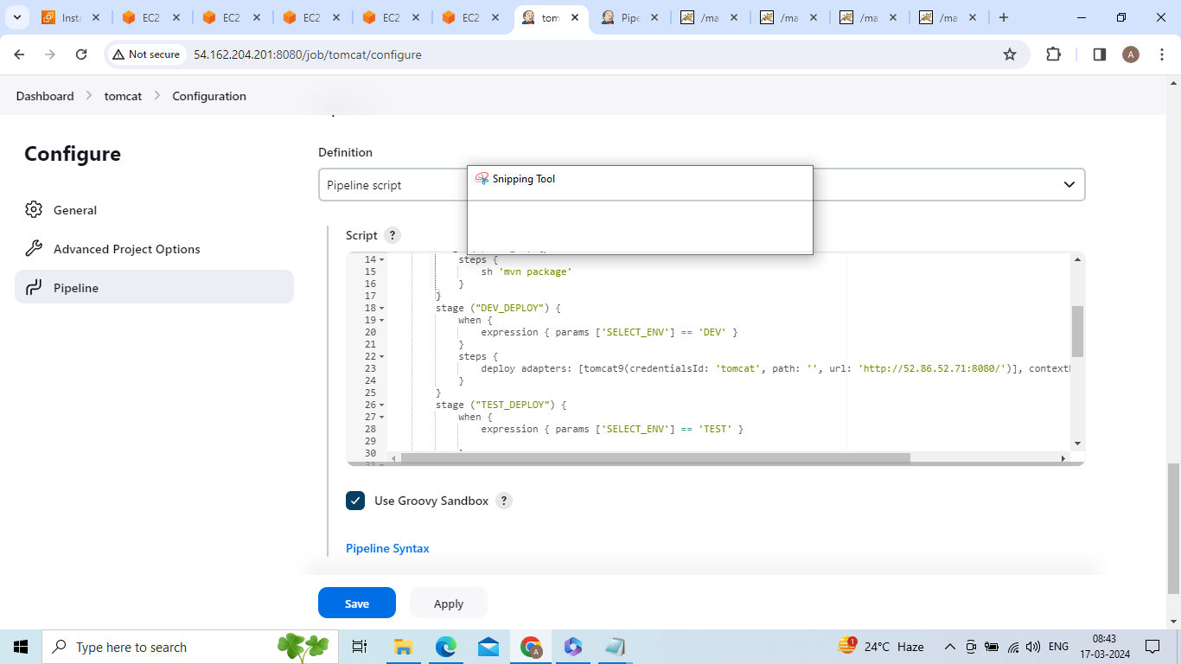

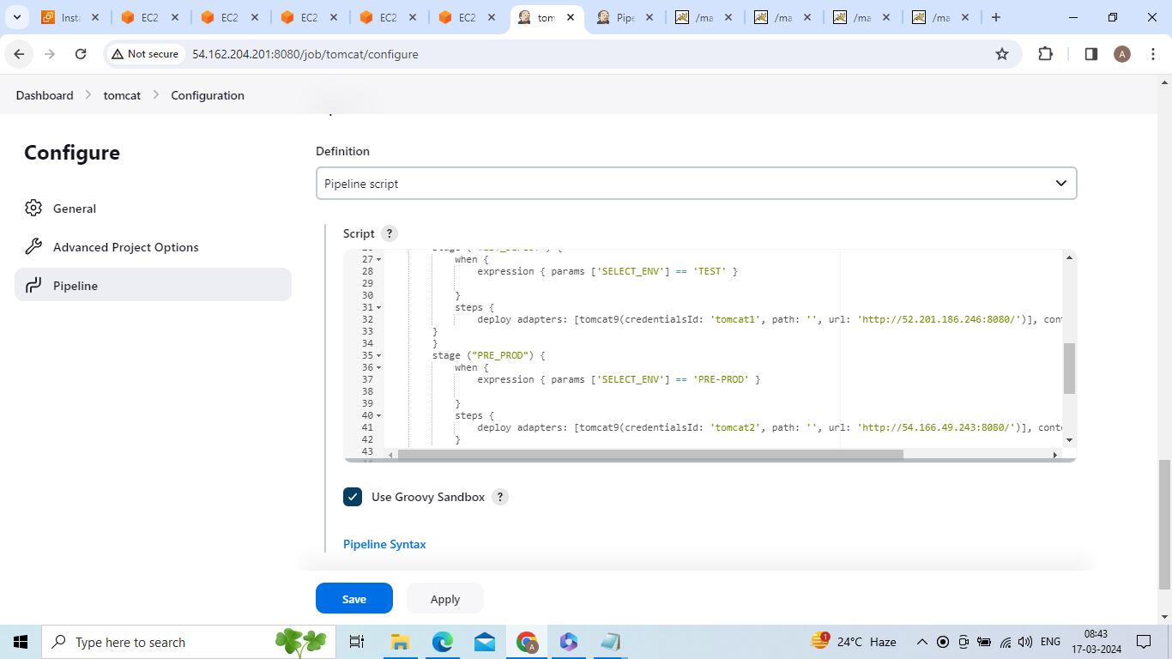

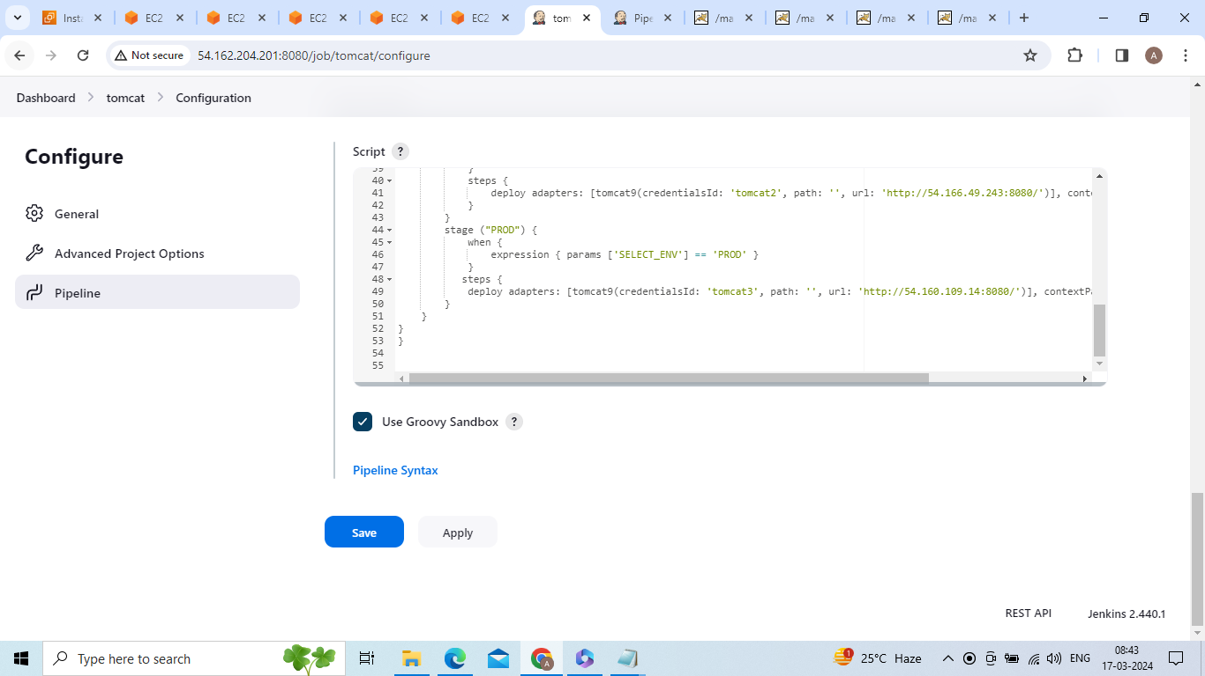

Build with parameters select one environment in DEV ,TEST ,PRE-PROD,PROD

I am selecting DEV

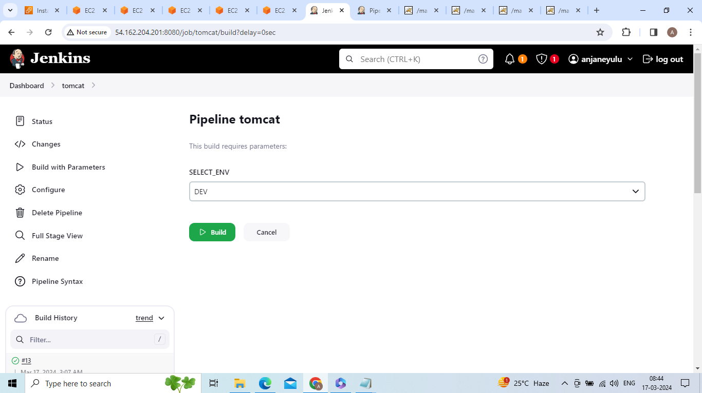

After clicking build output will be like below

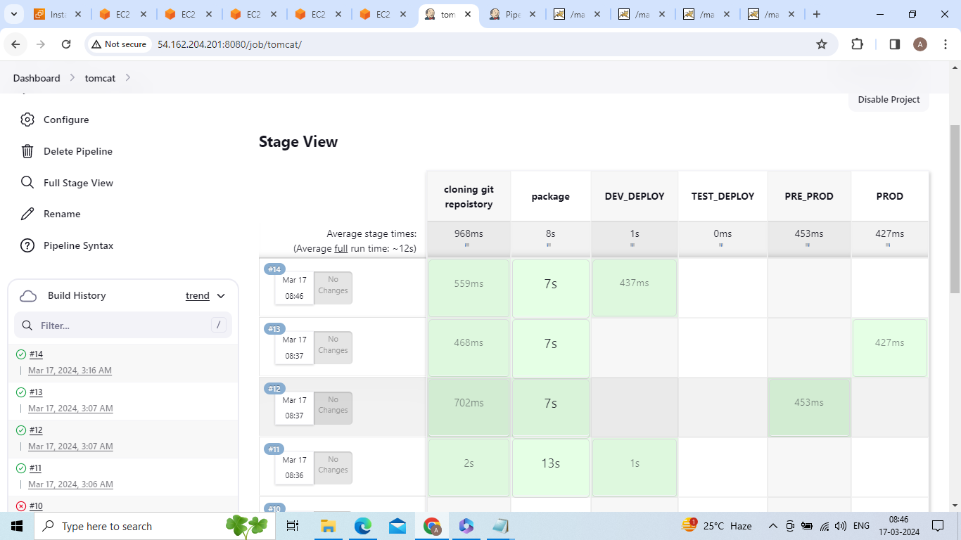

After excuting DEV environment go to DEV environmet tomcat web page and refresh and then we will see deployment of taxi-booking

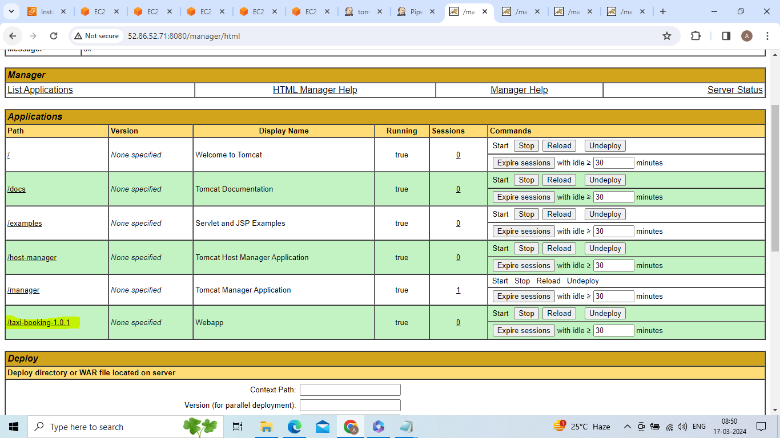

Click on taxi-booking-1.0.1 then we will see taxi-booking home page

